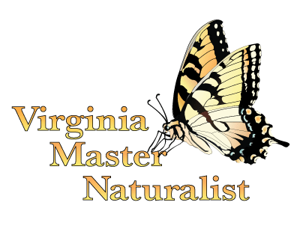
Virginia Master Naturalist Program
Basic Training Course Evaluation

We hope you are enjoying your experience as a new trainee in the Virginia Master Naturalist program. To make sure we keep improving our training materials to meet our volunteers’ needs, we would like to ask several questions to get your feedback on the training given to you today on Citizen Science and Research Skills. This will help us determine the quality of the materials we have developed and continuously improve them for future classes.

1. Please respond to the following statements: 1 = strongly disagree, 2 = disagree, 3 = neutral, 4 = agree, or 5 = strongly agree.

 | Strongly  Disagree |  |  | Strongly  Agree
Training goals and objectives were clearly stated | 1 | 2 | 3 |  | 4 | 5
Time allocated for the training was sufficient | 1 | 2 | 3 |  | 4 | 5
The instructor was effective at teaching the material | 1 | 2 | 3 |  | 4 | 5
The background readings I received were useful | 1 | 2 | 3 |  | 4 | 5

2. What was your level of confidence in participating in the following activities before and after the training: 1 = not at all confident, 2 = somewhat confident, 3 = confident, and 4 = very confident.

 | BEFORE THIS TRAINING…. |  |  |  | AS A RESULT OF THIS TRAINING….
 | Not At All  Confident |  | Very  Confident |  | Not At All  Confident |  | Very  Confident
Keeping a field notebook and recording data | 1 | 2 | 3 | 4 | 1 | 2 | 3 | 4
Using a dichotomous key to identify organisms | 1 | 2 | 3 | 4 | 1 | 2 | 3 | 4
Participating in the scientific process as a citizen scientist | 1 | 2 | 3 | 4 | 1 | 2 | 3 | 4
Following ethical standards as a citizen scientist | 1 | 2 | 3 | 4 | 1 | 2 | 3 | 4

3. What was your level of knowledge of these topics before and after the training: 1 = no knowledge, 2 = some knowledge, 3 = knowledgeable, and 4 = very knowledgeable.

 | BEFORE THIS TRAINING…. |  |  |  | AS A RESULT OF THIS TRAINING….
 | No  Knowledge |  | Very  Knowledgeable |  | No  Knowledge |  | Very  Knowledgeable
The types of citizen science field studies and their uses | 1 | 2 | 3 | 4 | 1 | 2 | 3 | 4
The process of science | 1 | 2 | 3 | 4 | 1 | 2 | 3 | 4
Opportunities for participating in citizen science as a VMN volunteer | 1 | 2 | 3 | 4 | 1 | 2 | 3 | 4
The role of Virginia’s state agencies in citizen science projects | 1 | 2 | 3 | 4 | 1 | 2 | 3 | 4

4. What overall rating would you give the training you received?

□ Excellent □ Good □ Average □ Poor □ Very Poor

5. Please provide any additional comments relevant to your experience participating in this training.

Virginia Master Naturalist programs and employment are open to all, regardless of age, color, disability, gender, gender identity, gender expression, national origin, political affiliation, race, religion, sexual orientation, genetic information, veteran status, or any other basis protected by law. An equal opportunity/affirmative action employer. Issued in furtherance of Cooperative Extension work, Virginia Polytechnic Institute and State University, Virginia State University, and the U.S. Department of Agriculture cooperating. Edwin J. Jones, Director, Virginia Cooperative Extension, Virginia Tech, Blacksburg; M. Ray McKinnie, Interim Administrator, 1890 Extension Program, Virginia State University, Petersburg.

