Dear Mr./Ms. ___________:

My name is _________________ and I am volunteering my time as a Virginia Master Naturalist.

We are assisting the Virginia Department of Conservation and Recreation (DCR) to determine the population status of some of Virginia’s less-common plant and animal species. In 19XX, the ___________________ was found near your property and recent aerial photographs indicate there is a chance habitat for this species may be on your land.

I would like permission to walk on your property to determine if the species or its habitat is indeed present. I would let you know immediately what (if anything) I find. DCR will use the information that I and other volunteers collect to analyze the state-wide population status of the plants and animals we are seeking and to plan effective, voluntary conservation actions to help conserve them.

I hope you can get back in touch with me soon. I can be reached by phone, e-mail or regular mail and my contact information is given below. Thank you for considering my request.

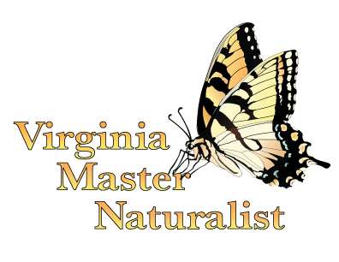
Sincerely,

First last
Address
Phone
E-mail

