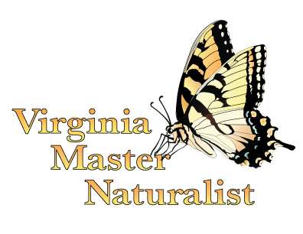
Outline
Virginia Master Naturalist Program Basic Training
Forest Ecology and Management
Presentation Handout

- Forest Basics
  - Forest Benefits: Some of the many benefits and ecosystem services forests provide include improving air quality, sequestering carbon, buffering waterways, protecting drinking water, reducing erosion, providing storm surge protection, providing wildlife habitat, providing lumber and wood products, and providing recreational and economic opportunities.
  - Forest Ecology Basics
    - Vertical structure – Forests have layers that include the forest floor, herbaceous plants, shrubs, understory trees, and the canopy.
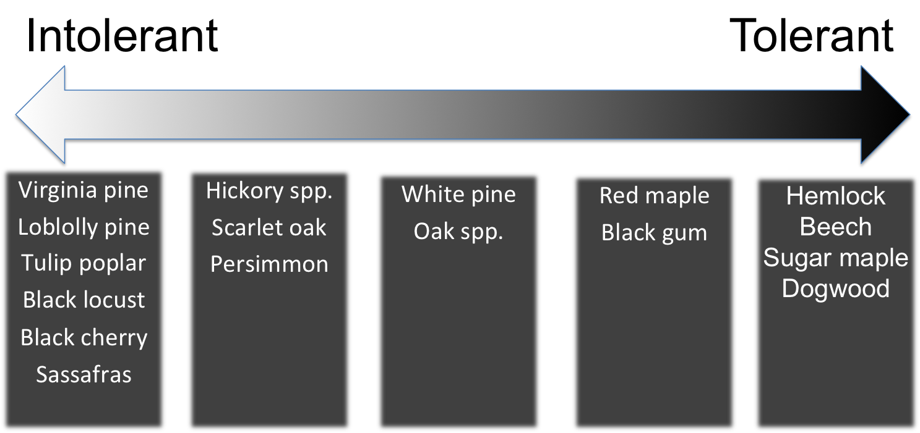
    - Age structure – May be even-age, two-age, or uneven-age.
    - Factors that influence where forests grow and the distribution and diversity of trees within them: soils, slope degree and aspect, light penetration, and disturbance such as fire, disease, timber harvesting, and even deer browsing.
    - Forest communities are always changing through a process called succession, which is the process of one plant community replacing another over time.
Figure 1. Shade tolerance of various Virginia tree species.
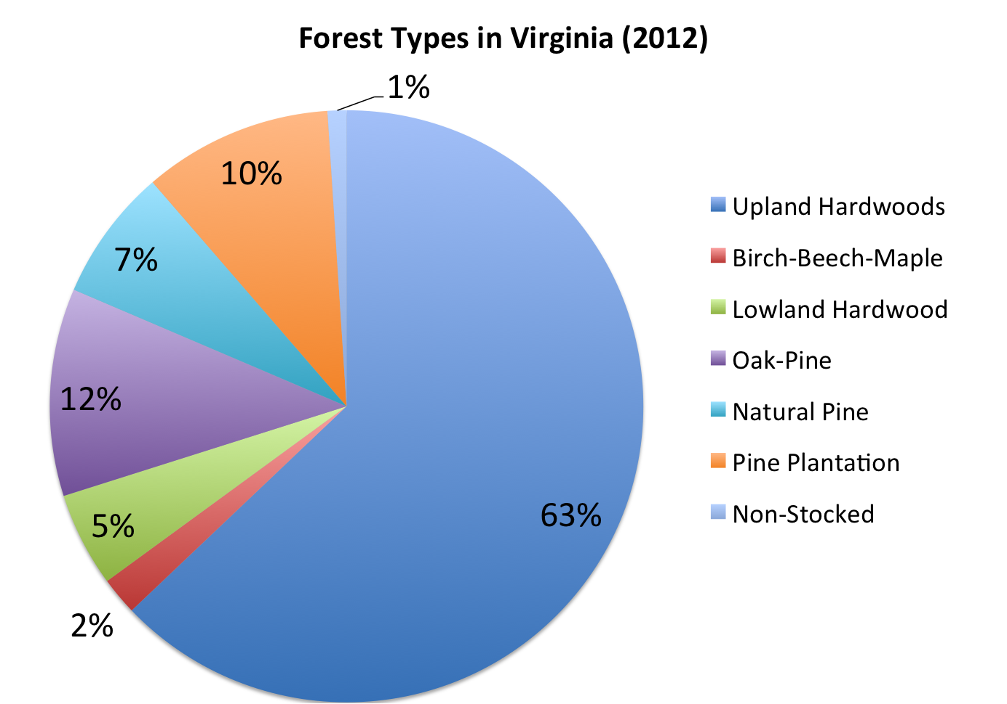
  - Forests Types In Virginia
~60% of Virginia is covered in forest, two-thirds of which is privately owned by individuals or families.
    - Oak-hickory: Most extensive type of upland hardwood community.
Dominant trees – various oaks and hickories, as well as beeches, maples, and tulip poplars.
Understory trees/shrubs – dogwood, sassafras, redbud, serviceberry, spicebush, mountain laurel, rhododendron
    - Bottomland hardwoods: Throughout Virginia on floodplains, riparian areas, and low-lying wet areas.
Figure 2. Forest types in Virginia, based on the 2012 Virginia Department of Forestry State of the Forest report.
Dominant trees – willow oak and other oaks, tupelos, and bald cypress on the coastal plain; sycamores, ashes, and red maples further west.
Understory trees/shrubs – buttonbush, sweetspire, greenbrier, poison ivy
    - Southern pine: Found throughout much of the coastal plain and piedmont.
Dominant trees – loblolly and shortleaf pines; longleaf pine restoration efforts are underway
Understory trees/shrubs – Sparse, but may include viburnums, dogwood, young hardwoods
    - White pine: Found from the Blue Ridge west, sometimes in pure stands.
Dominant trees – white pines, sometimes with tulip poplars, oaks, hemlocks, hickories.
Understory trees/shrubs – Sparse, but may include blueberries, mountain laurel, wild azaleas
    - Oak-pine: Transitional stage between early successional pines and later successional hardwood forest that can be maintained with fire.
Dominant trees – various pines and oaks, as well as tulip trees, maples, and gums.
Understory trees/shrubs – sourwood, dogwood, hollies, mountain laurel, blueberries.
- Threats to Virginia’s Forests
  - Development – Parcelization and fragmentation and conversion of forest to non-forest uses are decreasing the amount of forestland in Virginia.
  - Climate change – Changing temperatures and rainfall patterns will likely lead to range shifts for tree species and potential stressors that may affect disease susceptibility.
  - Invasives – Exotic plants, insect pests, and diseases are significant threats to forest health.
  - Historical extraction – High grading or selective cutting removes the best trees and leaves a degraded forest.

- Forest Management
  - Silviculture is the art and science of managing a stand of trees to meet specific objectives.
  - Forest management begins with a plan that is based on the objectives of the landowner. Those objectives could include any manner of forest uses (e.g., harvesting timber, recreating) and conservation goals (e.g., providing wildlife habitat, protecting a water source.)
  - Silvicultural systems focus on the future of the stand, rather than what you are removing. They may include site preparation, regeneration, intermediate treatments such as thinning, and harvesting.
  - The intensity of the management needed depends on the objectives. Some objectives, such as enhancing biodiversity, may require little or no input. Other objectives, such as producing timber quickly, may require high inputs.

- Related volunteer projects for Virginia Master Naturalists
  - Educational programs about the importance of forests for any audience
  - Forestry education stations at local Meaningful Watershed Educational Experience or field day events. Contact your local Soil and Water Conservation District and/or VCE 4-H agent to inquire.
  - Planning and installing interpretive trails and signs about forests.
  - Working Woods interpretive walks at historically significant destinations/sites (See www.valeaf.org.)
  - Education/interpretation on VDOF state forests, including the use of the “Tree Trunks” educational materials. Contact ellen.powell@dof.virginia.gov.
  - Environmental education for youth using Project Learning Tree or other forest-related curricula. See http://web1.cnre.vt.edu/plt/.
  - Educational programs on the American Chestnut using The American Chestnut Foundation’s Learning Boxes. Contact Matt Brinckman, matt@acf.org.
  - American Chestnut surveys and stewardship with The American Chestnut Foundation. Contact Matt Brinckman, matt@acf.org.
  - Surveying for and reporting new infestations of invasive species. See https://www.eddmaps.org or contact Kevin Heffernan, VDCR Natural Heritage Stewardship Biologist, 804-786-9112.
  - Invasives management or other stewardship in forests
  - Urban forestry projects (e.g., tree plantings and stewardship)
Funding for the development of this Virginia Master Naturalist Basic Training module was provided
by the Virginia Environmental Endowment.
Virginia Cooperative Extension programs and employment are open to all, regardless of age, color, disability, gender, gender identity, gender expression, national origin, political affiliation, race, religion, sexual orientation, genetic information, veteran status, or any other basis protected by law. An equal opportunity/affirmative action employer. Issued in furtherance of Cooperative Extension work, Virginia Polytechnic Institute and State University, Virginia State University, and the U.S. Department of Agriculture cooperating. Edwin J. Jones, Director, Virginia Cooperative Extension, Virginia Tech, Blacksburg; Jewel E. Hairston, Administrator, 1890 Extension Program, Virginia State, Petersburg.

