historic rivers bat monitoring project

Draft, February 15, 2018

Historic Rivers Chapter
Virginia Master Naturalists
P. O. Box 5026
Williamsburg, VA 23188

Bat Monitoring Project

Project Co-Leads/Contacts
Brenda Uekert (docbku@cox.net) and Wendy Nelson (vawendy@cox.net)

Mission
The mission of the Historic Rivers Bat Monitoring Project is to contribute to the conservancy of bats by:
- Documenting the local bat population over time.
- Contributing data to the North American Bat Monitoring Program (NABat).
- Participating in scientific studies that explore migratory patterns and the health of bat species.
- Educating the public on the importance of bats to our environment.

The bat monitoring protocol is based on protocols developed in Pennsylvania , Wisconsin and Fort Collins, Colorado. The bat monitoring season is divided into warm months and cool months, and activities will vary accordingly.

Warm Season: Acoustic and Emergent Monitoring
Acoustic Monitoring will occur in the spring and summer. The season will start when temperatures rise above 50 degrees and is expected to end in early October. There are three activities that will take place during this season:
- Acoustic monitoring
- Summer maternity roost monitoring
- Participation in the North American Bat Monitoring Program (NABat)

Acoustic Monitoring
Our acoustic monitoring is based on the protocols developed by Fort Collins North American Bat Monitoring Program (NABat).
The purpose of NABat is to “create a continent-wide program to monitor bats at local to range-wide scales that will provide reliable data to promote effective conservation decision-making and the long-term viability of bat populations across the continent.”
NABat collects monitoring data a few days in the summer. To gain a more complete picture of the bat population in our area, we will start monitoring in the spring, when the bats emerge, and continue until hibernation (or migration). The data will help us document the population, species, and migration of local bats. Additionally, long-term monitoring will contribute to trend data that is particularly critical to estimating the health of the population. The primary method to collect acoustic data is through driving transects.

About Driving Transects
Driving transects is an approach developed by the Fort Collins group, which has provided the Historic Rivers Chapter with a priority transects map (see Figure 1). Each cell is 10 x 10 km (6.2 sq miles). The cells highlighted in red are the six transects prioritized for monitoring by Fort Collins.

Figure 1: Priority Transects for Williamsburg/James City County/York County Virginia

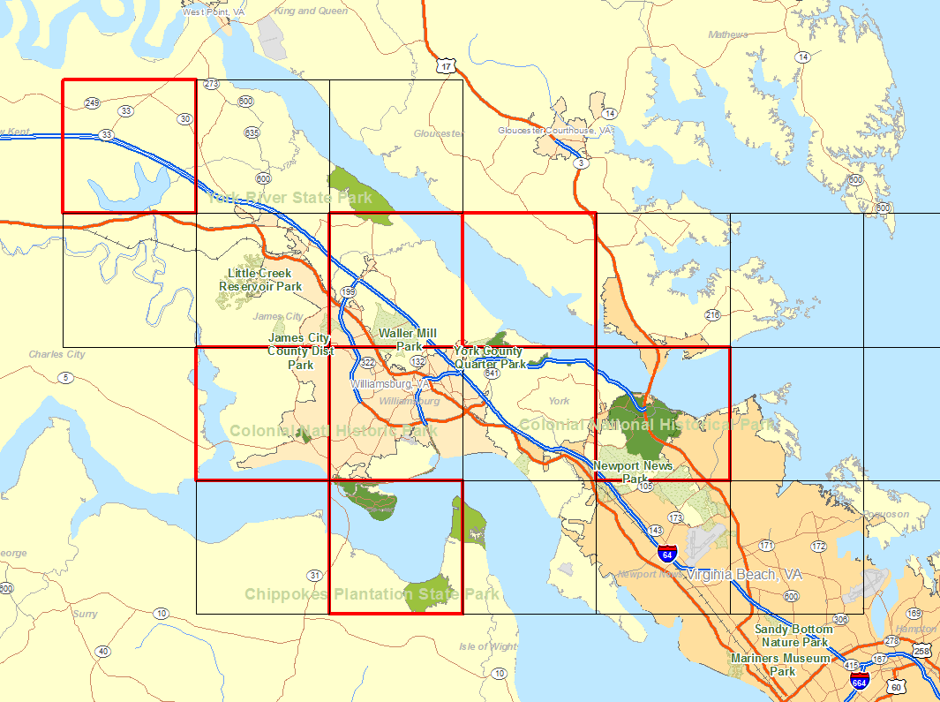

Driving transects require considerable safety measures to be taken by HRC volunteers, which are outlined in Appendix A. Risk management protocols should be followed at all times. The same transects are driven multiple times during the summer. A typical vehicle can accommodate two to five people. With two sets of monitoring equipment and software, we can accommodate four to ten persons if simultaneous surveys are conducted. If surveys are done frequently, we can use many teams of people throughout the summer. This is similar to the bluebird monitoring project, in which volunteers are assigned to a trail and participate throughout the season.

Equipment Note
After considerable research, the HRC bat squad, in consultation with the Fort Collins experts, has selected the SonoBat – 4 Base with the Pettersson M500 Microphone. This software/microphone combination is better equipped to handle driving transects and the higher quality microphone is better calibrated to detect species.ikely to be less with software license)

Timing of Surveys
Surveys should begin 45 minutes after sunset. Driving should commence as soon as the detectors are set to “Record,” and detectors should be stopped as soon as the end of the transect is reached. Here are a few tips:
- The equipment should be tested by rubbing fingers or jangling keys in front of the microphone immediately prior to the beginning of the transect run and just before the detector is shut off. This allows surveyors to determine if the equipment was functional throughout the survey, especially if no bats are recorded at the end of the transect.
- Surveys should occur on nights when there is no rain or fog, low wind speed (< ~10 km/h / 6.2 mph), and, if possible, during a new or quarter moon.
- Wet roads and puddles can affect quality of calls recorded because of increased road noise from tires. Thus, these conditions should be avoided if possible, or noted.
- Nights that are exceptionally cool for the area should also be avoided.

The route should be recorded with a GPS and submitted as metadata in the BPD as an ArcGIS® shapefile

Bat activity and habitat use can be affected by a large variety of factors including habitat type, temperature, relative humidity, rainfall, wind, and moonlight. Many factors related to equipment placement and setup can also affect the data. Many of these factors can be controlled for during the analysis phase if they are known. Data that should be collected is listed in Appendix B.

Summer Maternity Roost Monitoring
Several states have a centralized data collection site. Virginia does not yet have this level of information, though it is foreseeable that they will in the near future. In the meantime, the Historic Rivers Chapter will document and track data electronically, which will be sent to the state should that become an option. It’s a great opportunity to take a leadership role in citizen science data collection. Many aspects of the roost monitoring protocol are based on those practiced in New Hampshire.

The Goals of the survey are to:
- Gather baseline information on summer bat colonies
- Evaluate the impact of White-Nose Syndrome (WNS) on summer bat colonies

The survey methods described below will be used to:
- Identify the location and evaluate the approximate size of bat maternity roosts by conducting general emergence counts (number of bats exiting the roost at night)
- Compare pre-volant (before pups can fly) and post-volant (after pups start flying) counts using more extensive surveys at some locations.

Commitment Levels
Bat counts take about an hour and a half in an evening, starting a half hour before dusk. The initial commitment is to conduct one baseline emergence count of a maternity roost site per year. It is hoped that volunteers will commit to conducting multiple surveys over the next several years.
Bat Reporter - Conduct one (or more) emergence counts of a roost between May 15th and July 31st. Base line information on many roosts is extremely valuable. If conducting only one count, try to conduct in mid-July when the colony should be most stable.

Bat Tracker - Conduct at least one (preferably 2) emergence counts of a roost between June 3rd and June 23rd before most pups begin flying (pre-volant) and at least one (preferably 2) emergence counts between July 8th and July 28th after most pups begin flying (post-volant).

Bat Enthusiast - Conduct at least one emergence count of a roost every 2 weeks (preferably every week) from May 15th through July 31st.

Some maternity colonies begin to disperse (break apart and spread out to other locations) soon after pups begin flying (post-volant). For intensive research purposes, it is also recommended that you conduct two or more counts on consecutive evenings.

Documentation Forms/Online Surveys
There are two forms (see downloadable forms here)
- Site and Landowner Data Form
- Emergence Count Data Form
Both forms can be turned into online survey forms using free software, such as SurveyMonkey. It will be the responsibility of volunteers to enter data after each emergence count. Appendix C lists the type of data to be collected in the emergent count protocol.

How to Conduct the Survey
- Find a bat colony. Barns, attics and other old structures provide the best opportunities for finding bat roost sites. The largest colonies are usually located along major rivers or other large bodies of water and other colonies can be found most everywhere near forests and water. Often local colonies are known and you can ask your neighbors if they know of any locations.
- Scout to determine where bats are exiting. You may find that you need help in covering all the exits (front and back of a structure). Please remember to ask permission of the landowner and enjoy the experience.
- Choose an evening when the temperature is 50ºF with light wind and no rain. Bring a paper and pencil and the Bat Colony Count Data Form. Arrive ½ hour before sunset and continue the survey until 1 hour after sunset or until it is otherwise too dark to see emerging bats.
- Fill in the Emergence Count Data Form noting the observers and weather conditions and start time. Give a pencil and blank paper to each surveyor. On the blank paper make two columns. In one column you will make a tick mark for each bat as they exit. In the other column you'll make a tick mark for bats that re-enter the building.
  - Position both yourself and helpers so that someone has a view of each side of the building and so that you can communicate easily. It is best to be in position to have the bats silhouetted against the sky for easiest viewing. (Wearing a hat helps to reduce glare from the sky.)
  - It is important to keep noise and light to a minimum while bats are emerging. As the sun goes down, it will take a while for the bats to start emerging, and then they tend to come out over about an hour.
  - If you find that you have a mega-colony that numbers in the thousands, you may need to tally the bats by the 10’s as they exit.
  - Count only the bats entering or exiting the building - as opposed to bats flying by you. As the bats exit, if you see one going toward another observer let them know.
  - Stop counting when either 15 minutes has passed since the last bat emerged or when visibility is gone.
- Tally all the bats exiting and re-entering the roost and enter it on the Emergence Count Data Form. Remember to note the start time and the end time. Note any observations (e.g bat behavior, newly discovered exits, etc.) from the surveyors.

North American Bat Monitoring Program
The project will include participating in a four-day national bat census, headed by the Fort Collins Science Center, as part of the North American Bat Monitoring Program (Continental Scale Monitoring).

We will be following the acoustic monitoring protocols listed above, but our activity will be confined to a four day period specified by Fort Collins NABat program.

Cool Season: Building, Erecting and Monitoring Bat Houses
Tentatively, in the fall and winter season, the HRC volunteers will assist Virginia Tech with the collection of migratory data. Additionally, activities may include building, purchasing, placing, and monitoring bat boxes.

Appendix A: Special Route Considerations

Safety. One of the first considerations when choosing a route is safety. The route should be safe to drive at 20 miles per hour with minimal stopping. Thus, roads that receive heavy traffic during the survey period should not be used, as this will require pulling off the road to let other vehicles pass or endanger the surveyor and other drivers as they try to pass the survey vehicle. Further, very rough roads where speeds of 20 mph are dangerous should not be used. Drivers should use their hazard lights to warn others of their slow speed. Headlights should always be used while driving the transect.

Road Types. In general, roads should be two-lane secondary or tertiary roads with few if any stops. Roads with gates that require opening and closing should not be used. Secondary roads include state highways and county roads, and tertiary roads include county roads and forest roads. Some gravel and dirt roads that are well maintained and allow consistent travel at 20 mph can also be used. The route should be driven prior to the first survey to ensure that the road can be safely driven at the appropriate speed and the driver is familiar with the route. The test routes should be driven at the proposed start time and speed.

Route Configuration. Routes should be approximately 25 to 48 km in length and fit primarily within the 100-km2 grid cell (e.g., fig. 5.1). If the route extends beyond the grid cell edges due to its length, the beginning and end of the transect can be in adjacent grid cells. One of the assumptions of the mobile transect method is that individual bats are not counted more than once, allowing calculation of an index of relative abundance (Roche and others 2011). Thus, the route should not cross back into the likely travel route of a bat, as this may result in the same bat being counted more than once. Sections of the route should be >100 m from each other if the route contains many curves or switchbacks. The surveyor should maintain a speed of ~32 km/h as consistently as possible throughout the survey period. If a stop is required, the detector should be paused and this should be noted.

Habitat Types. The route should pass through common habitat types of the area as much as possible. Depending on the location, this may include agricultural areas, forests, wetlands, and residential areas and small towns if traffic is not too congested. Urban areas can be important areas for some species of bats but may need to be surveyed with stationary point surveys due to the difficulty of maintaining a constant speed. When selecting the route, areas with dense forested corridors and a low canopy should be avoided or minimized to decrease the chance of recording high-clutter calls. There should be at least 3 m between the vehicle and the overhanging canopy (see sec. 4.4.1). Roads that parallel waterways (e.g., along a river or lakeshore) are often adequate to pick up species associated with water.

Appendix B: Data Collection Parameters for Transect Monitoring

- Site
- Grid cell ID
- Surveyors
- Years of Experience
- Moon Phase
- Habitat type
- Survey start/end
- Temp, wind & humidity at start and end
- Time start/end

Other data will be preset – microphone orientation, settings, software, file format – and will be consistent throughout unless extra equipment is procured.

Appendix C: Data Collection Parameters for Emergent Count Monitoring

The following data should be collected and recorded. Much of the data will need to be collected once per site and will be unlikely to change. Data collection parameters include the following:

- Roost structure Cave, mine, bunker, barn, tree, bridge, etc.
- Estimate method Survey methods (visual, photographic, video, etc)
- Colony type Maternity, bachelor, hibernaculum, transient, mixed Colony counts )
- Roost size

- Vertical distance (m) Height of bats in structure

- Horizontal distance (m) Distance between observers and bats

- Presence of water
- Roost protected? Locks, gates, restricted access
- Roost accessibility
- Signs of disturbance - evidence such as predation, graffiti, flooding, or collapsed walls or ceilings
- Other roosts? Number and distances of known roosts in the vicinity

